Vincent Van Gogh
Intro to Drawing
By: Katie Haley

Vincent Van Gogh was one of the most famous artists of his time. Van Gogh was born on March 30, 1853 in Zundert Holland. He was born into a very religious family, his dad being a pastor. Growing up was a struggle for him because he suffered from severe mental challenges. His parents noticed it at a very young age but the doctors told them nothing was diagnosable. He acted out in school, or didn’t act out enough. He was very quiet, but would throw tantrums if he didn’t get what he wanted right away. He was smart but in being very smart he was extremely serious, too serious for a young child to be. He didn’t enjoy playing and be a “kid” as much a professionals though he should be. Van Gogh’s mental health never improved as he got older, in fact it got worse, much worse.
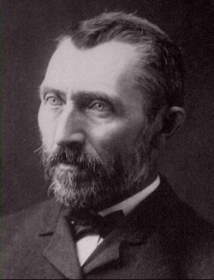
After High school Vincent Van Gogh became an art dealer. During his travels selling art work, he realized he truly wanted to become a clergyman. He then decided to go to college to follow in his father’s footsteps and become a pastor. After many years of struggling in school he dropped-out and became a missionary. During his missionary work his mental health got in the way and his father stepped in, prompting him to check himself into a mental institute. He obviously didn’t listen to his father, and this is when he began drawing and practicing his artistic abilities.
Vincent Van Gogh began his art career at age 27. During his career he created over 900 painting and drew over 1,100 works. He mostly taught himself his drawing and painting skills. Van Gogh gained his footing as an artist by copying pictures and studying nineteenth-century drawing manuals and lesson books, such as Charles Bargue's Exercises au fusain and cours de dessin. He thought that it was necessary to master black and white before working with color, and first focused on learning the rules of figure drawing and capturing landscapes in correct perspective. In 1882, he moved away from home to Hague, where his learned some painting skills from his cousin, Anton Mauve, a high level Hague School artist. That same year, he painted his first independent works in watercolor and ventured into oil painting. He also received his first payments for a painting as an artist: his uncle, the art dealer C. M. Van Gogh, commissioned two sets of drawings of Hague townscapes for which Van Gogh chose to depict such everyday sites as views of the railway station, gasworks, and nursery gardens.
Vincent Van Gogh’s painting style is considered to be called post impressionism. It’s the idea of going against the natural impressionist while experimenting with color, lines, and form, and of course his own emotions. Many people dispute whether or not Van Gogh’s drawings were affected by his mental health.
He had a mental breakdown cutting off part of his own ear after a big dispute with his close friend. The story of him cutting off his ear is also disputable because he claims that he cut off his own ear, and historians believe that his friend did it accidentally when they were arguing. Van Gogh supposedly made up the story to protect his friend from prosecution. After their argument Van Gogh ran away and gave his ear to a prostitute, while he was running home. He laid in his bed bleeding to death that night. Luckily the prostitute found his behavior very odd and ran to the police. They found Van Gogh in his home, and were able to save him. In fear of another mental breakdown he admitted himself into an insane asylum. Before Van Gogh was admitted to the asylum doctors diagnosed him with a hereditary disease called, porphyria, which is caused by an abnormality in hemoglobin, causing mental disturbances and extreme sensitivity to light. Along with his disease he had a serious alcohol addiction to Absinthe, which was an old liquor.
On May 8, 1889 van Gogh voluntarily entered the asylum of St. Paul near Saint Remy. Saint-Paul, which began as an Augustine Monastery in the 12th century, was converted into an asylum in the 19th century. It is by cornfields, vineyards and olive trees, Van Gogh received two rooms, one for him and one for a painting studio. His room’s windows were barred as a safety precaution. Van Gogh was initially confined to the immediate asylum grounds and painted (without the bars) the world he saw from his room, such as ivy covered trees, lilacs, and irises of the garden. Through his window Van Gogh could also see a wheat field, which was the focus of many of his paintings at Saint-Remy. As he was allowed to go outside of the asylum walls, he painted the wheat fields, olive trees and cypress trees of the surrounding area. Over the course of the year, he painted about 150 canvases.
The strictness of living at the asylum gave Van Gogh more stableness in his life. One of his quotes that seemed to be encouraging, "I feel happier here with my work than I could be outside. By staying here a good long time, I shall have learned regular habits and in the long run the result will be more order in my life." While his time at Saint-Remy forced him to deal with his issues, such as coffee, alcohol, poor eating habits and occasional attempts to eat turpentine and paint, his stay was not ideal. He had to be granted permission to leave the asylum grounds. The food was not good, he generally ate only bread and soup. His only form of treatment were two-hour baths twice a week. Which of course now is NOT a form of treatment, just a way of relaxing. During his year there, Van Gogh would have periodic attacks, possibly due to a form of epilepsy. By early 1890 van Gogh's attacks worsened and he believed that his stay at the asylum was not helping to make him better. In May of 1890 he moved to Paris.
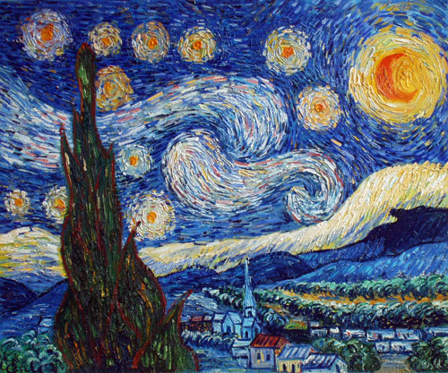
His most famous painting was painted while he was in his asylum, one of the views from his window, which is called “Starry Night”. He wasn’t allowed painting supplies in his room so he did this painting solely from memory. It was never sold but is insured for more than 100 million dollars. It currently resides at the Museum of Modern Art, in New York City. While living in Paris he painted much more, including the “Starry Night Over the Rhone”, which was a scene near his home in Paris that he enjoyed. It is also very valuable and famous. His most expensive painting ever SOLD was “Dr. Gatchet” which sold for 82.5 million dollars. It is estimated to be worth around 151 million dollars now.
During the course of Van Gogh’s life he wrote many letters. 928 of those letters are still around today. He wrote 844 of them and received 84. 650 of the letters were written by Van Gogh to his brother Theo, while he was in the asylum and out of it. The letters were found by Theo’s wife after he had passed away, in a drawer in his desk. They are now published and compiled into a book which is for sale worldwide. Van Gogh didn’t like to keep much of anything he ever received while in his asylum, that’s why many of his letters aren’t around anymore. The letters provide so much insight into his mind, and that’s why historians know so much about his personal life. The letters may not have seemed important to keep to Van Gogh but it is a great historical discovery to have these letters on document.
Vincent Van Gogh died on July 29, 1890. Not very long after he was released from the insane asylum. He died from a gunshot wound to his chest. He died two days after he was shot. This story is another one of Van Gogh’s many mysteries. He is believed to have shot himself in an attempt of suicide, but a conflicting story suggests that he was shot accidentally by a boy who was coming to him to help him fix his broken gun. The gun fired and killed Van Gogh. Neither story has ever been proven, but it was dramatic way to leave this world, but he was a very dramatic person.

My Impressions and Feelings of Vincent Van Gogh
I really enjoyed writing this paper and making a presentation about Vincent Van Gogh. I have always enjoyed his work but never knew much about him, and what I did know was of controversy. He seemed so confused and tormented by his own mind his whole life. I felt sorry for him that he had to spend many years in an asylum where they didn’t know how to tend to his disease, making it impossible to get better. His art on the other hand is absolutely beautiful to me. I like the idea of post impressionism, how he painted, with the swooshing of color and lines together, making the form more abstract. My favorite is of course, Starry Night. I like all of the color and how unique it is to his style of painting. I think there is happiness in the painting although he was in an asylum where he wasn’t happy and felt trapped. Many people know Van Gogh for cutting off his ear, and being a raging alcoholic, many of those people who just know him for that have the opinion that his work is only famous because of his crazy habits. I think that his crazy personal habits only make his work that much better because it helps me understand what he was thinking and feeling when he painted particular paintings. He lived over 100 years ago and his work still influences so many artists all around the world. I have never had an art class where his name wasn’t mentioned. I believe that he used his art as an escape to run away from his own mind. He had such a twisted mind that if he hadn’t had art he probably would have ended his life much sooner than he did. I value the way he self-preserved himself. He knew he had a mental instability and decided to channel his negative mentality into something that became beautiful and world renown. Vincent Van Gogh has become one of the most popular artists of all time, and I think that people need to start recognizing him for his art achievements not for his mental instability.

