How to Make a Tie Blanket
By: Katie Haley
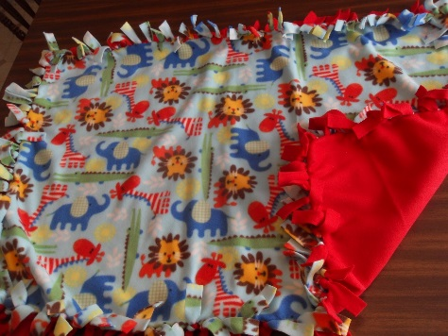
Have you ever needed a warm blanket to snuggle up under, but didn’t have one? Now you won’t have to be cold another day longer. Let me show you a simple way to make a warm fleece blanket that can be designed to fit your personality.
Making a tie blanket is a great craft to make with friends, your family, or even something fun to do on a rainy day. It is so much simpler than making a quilt or buying an expensive comforter in a store. It doesn’t require any sewing or pinning, and is much cheaper than a store bought blanket. There are only a couple of items needed for this project and a few steps, then you will have successfully made your own personal tie blanket. Fleece blankets are made by tying two pieces of fleece together to make a double layered blanket.
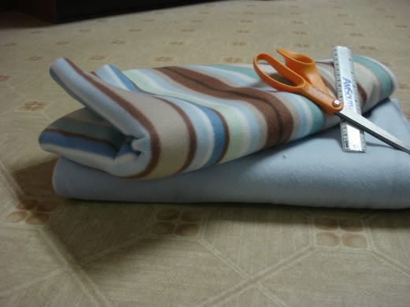
The items that are needed to make your tie blanket are fleece, a ruler, and scissors. You can buy fleece at many different stores. Craft stores are your best bet, like Hobby Lobby and JoAnn’s Fabrics. Fabric is also available at Walmart. There are other stores that sell fleece but these are the stores that I go to. Of course scissors can be purchased at many stores but I highly recommend buying scissors that are specifically for cutting fabric. You do a lot of cutting in this project and it is good to have sharp scissors so that your hand doesn’t get sore.
Here’s a quick tip for best results with your fabric. It is best to have the same sides of the fabric facing each other, so that the better quality side of the fabric is facing out. To determine the sides of the fabric grab the edge of the fleece and pull, whichever way the fleece rolls in toward is the side that is of less quality and should be faced inward.
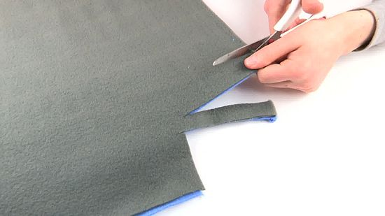
The first order of business is to pick out fleece. Your blanket can be made in a couple different ways, you can use the same pattern or a solid piece of fabric for both of the sides, or use a patterned piece and a solid piece for either side. Once you have decided on which fleece you want you will need to decide how big you want your blanket to be. Once you have decided on the size you want, lay out your material on your work place. I suggest the floor because it is good to spread out the blanket and not move it once you start cutting. Now you will want to determine how long you want your ties to be. A good length is 3-6 inches, it makes it easier to tie. On each corner of your fleece cut out a square the length you want your ties to be.
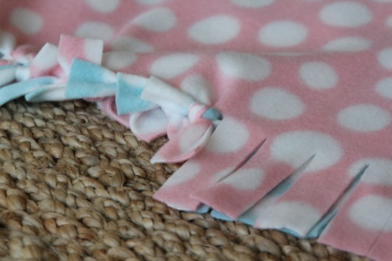
Now the main step is to begin the cutting of the strips. It doesn’t matter which side to start on, but it is important to stick to a side and work your way around the blanket. If you start on one side and then move to the other your fleece can get moved around and won’t be lined up anymore, making it hard to line up the pieces for cutting. Cut your strips an inch wide and however long you decided on. Do this all the way around the blanket. Once every edge is cut you can now start tying. Make sure that you are lining up every top piece with the bottom piece directly under it. If you don’t do this pieces will be left untied and it could make your blanket look dysfunctional. Make sure to tie the two strips in double knots so they don’t come untied.
You now have your completed tie fleece blanket! It was very quick and easy to make and now you’re well on your way to trying the more advanced patterns of tie blankets. Don’t stop the tying now, these blankets make great gifts for family and friends, and remember just have fun!

